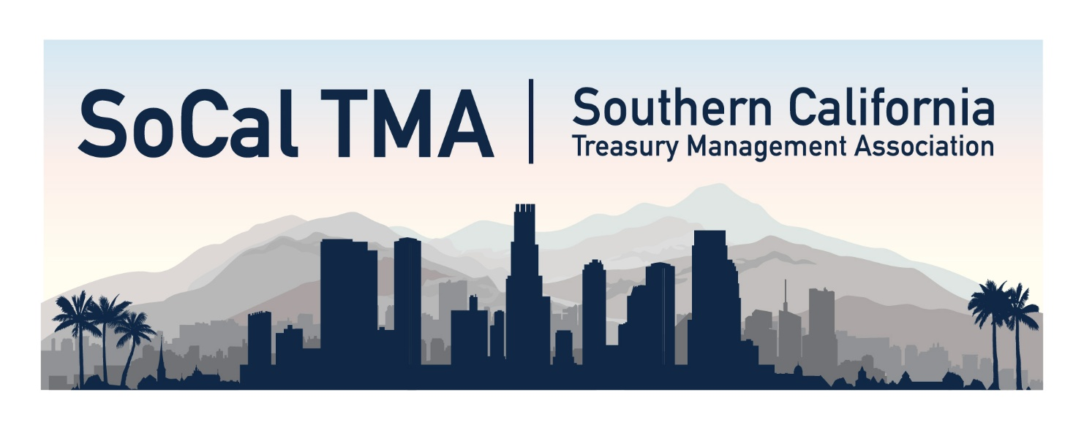Self-Certifying
Certificate of Attendance
We certify that _____________________________ participated in the following continuing professional education program and
attended the _____________________________________ session.
Southern California Treasury Management Association
Nov. 18, 2025| Marriott Long Beach Downtown, CA

Total Self-Certifying Continuing Education Credits Earned __________

Jennifer Saliba  Event Director: | Jennifer Saliba
Participant’s signature:

* This program is designed and administered to qualify for the noted hours of credit. However, each participant is responsible for claiming credit only for the actual hours of attendance.

